**Yakou superstation**

This dataset includes data recorded by the automatic meteorological station (AMS) and snow cover observations from 2014/01/01 to 2014/12/31. The site (100.24° E, 38.01° N) was covered by Alpine meadow and located in the Dadongshu Yakou, Binggou town, Qilian County, Qinghai Province. The elevation is 4148 m.

An overview of the measured variables and sensor specifications of the tower (Tower1) are summarized in the following Table:

|  |  |  |  |  |
| --- | --- | --- | --- | --- |
| Variable | Unit | Corporation/Sensors | Height | Direction |
| Air temperature | ℃ | Vaisala/HMP45AC | 5 m | north |
| Air humidity | % | Vaisala/HMP45AC | 5 m | north |
| Wind speed | m/s | MetOne/010C | 10 m | north |
| Wind direction | ° | MetOne/020C | 10 m | north |
| Four-component radiation  ((DR/UR/DLR_Cor/ULR_Cor) | W/m2 | Kipp&Zone/  CNR4 | 1.5 m | south |
| Air pressure | hpa | Setra/CS100 | 0.5 m | / |
| Soil heat flux | W/m2 | Hukseflux/HFP01 | -6 cm  (2 Repeats) | / |
| Soil temperature | ℃ | CSI/109 | 0, -4, -10, -20, -40, -80, -120, and -160 cm | / |
| Soil moisture | % | CS/CS616 | -4, -10, -20, -40, -80, -120, and -160 cm | / |
| Snow depth | m | CSI/SR50A | 2.5 m | / |
| Snow water equivalent | mm | CSI/CS725 | 2.5 m | / |
| Drifting snow | g/m2/s | IAV/ FLOWCAPT | 0-1, 1-2, 2-3 m | / |

The missing data are denoted by -6999, which include four-component radiation (ULR_Cor and Rn) from 2014/08/13 to 2014/12/31 due to sensor breakdown.

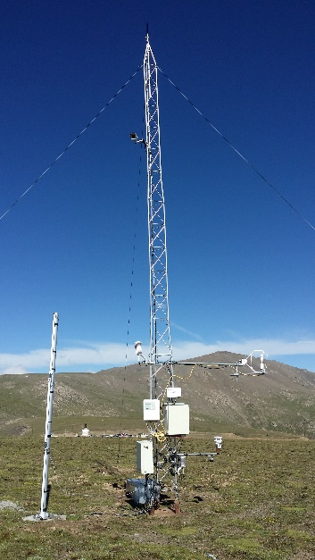

Tower1